Cins Face Recognition using Deep Learning

Machine Learning Homework3

**Code Explanation and User Manual**

**Erdoğan Abacı**

**150315025**

[erdoganabaci97@gmail.com](mailto:erdoganabaci97@gmail.com)

Computer Science Engineering

Celal Bayar University – Manisa/Turkey

June 01, 2019

Firstly; I wrote the code with python and my compiler is spyder.I Imported these libraries.

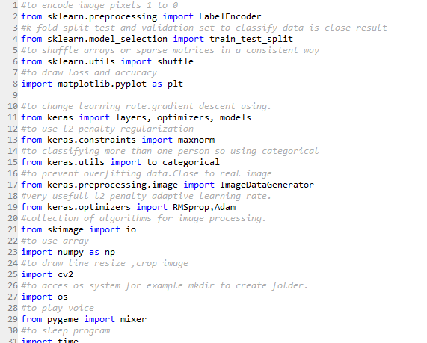

Take first %70 sample as train data and last %30 sample as test data.Train images pixel and get save models

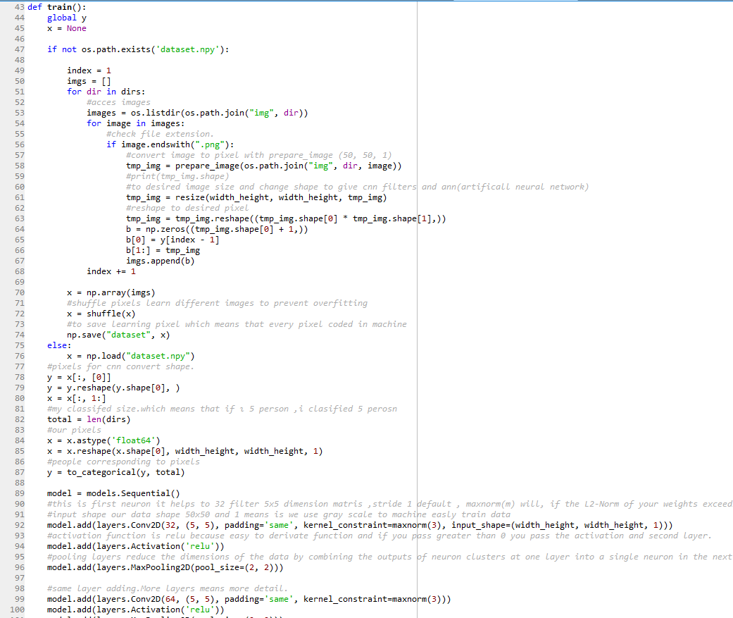

Resize and Crop images to scale image to prepare train

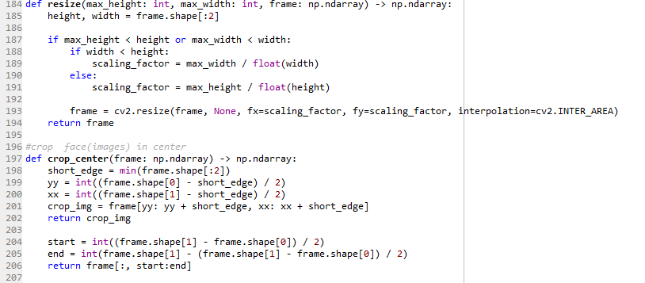

Detect Face with Model

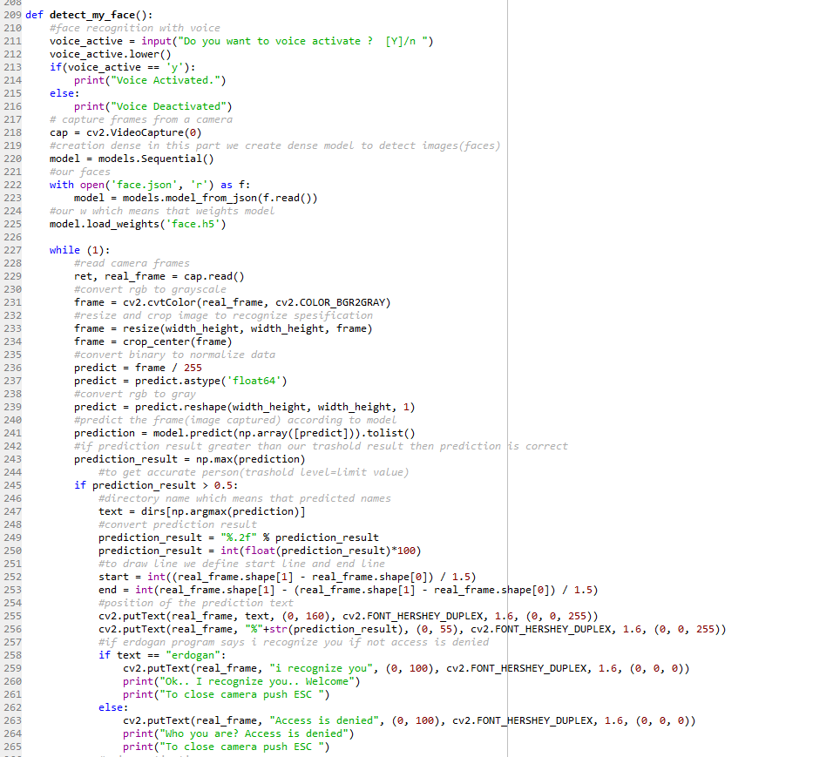

Prepare image to convert image to pixel **normalize pixels**

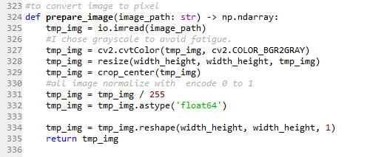

Save image to create image data my own datas with capture the camera

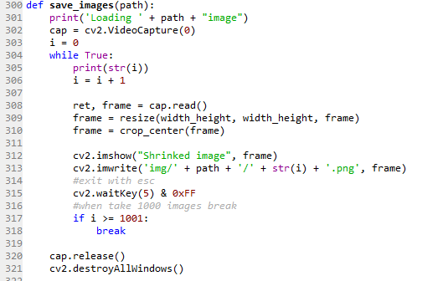

**User Manual**

Download Libraries if you use anaconda with anaconda prompt

**-** **conda install -c conda-forge keras**

**-** **python -m pip install matplotlib.pyplot**

**-** **python -m pip install numpy**

**If you want to train you have to use gpu provide tensorflow-gpu.It help to parallel cuda gpu train data.Otherwise use it cpu.**

**-pip install tensorflow-gpu**

**To run command**

python face.py

**If you want to exit from camera you can push ‘esc’**

**Code output**

X train images (I commented 48 and 62 code lines)

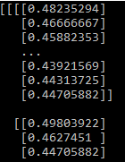

Figure X train

Y train values

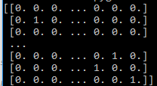

Figure Y train

**Number of Iteration(epoch) neural network start to learn**

I commented because I have already trained my img folders data

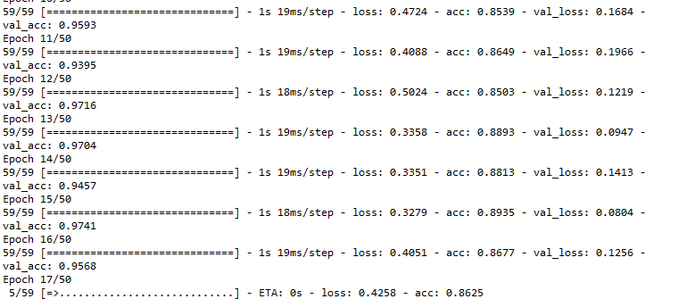

Figure Epoch

**Loss decrease Model accuracy increase and W size and minimized w values**

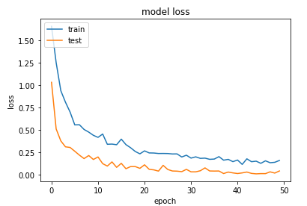

Figure Model Loss

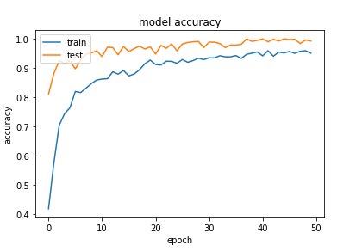

Figure Model Accuracy

**If recognize me then say , I recognize you otherwise , acces denied**

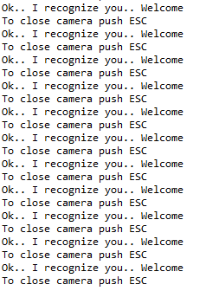

Figure Recognize You

**If you open voice time.sleep(5) which means that every 5 second check who am I? with take a frame.**

**If you want to exit from camera you can push ‘esc’**

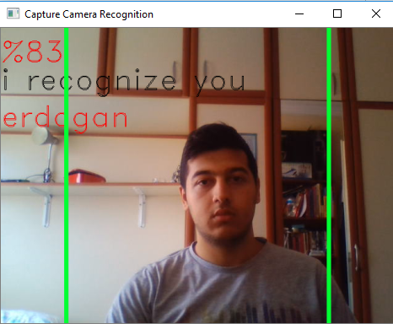

Figure My Real Time Capture Camera :)